**TWO PORT NETWORK**

Table 1: Z parameter of circuit 1

|  |  |  |  |  |
| --- | --- | --- | --- | --- |
| Z - parameters | Z11 | Z12 | Z21 | Z22 |
| Simulation | 3.4364k | 1.5618k | 1.5618k | 3.4364k |
| Calculation | 3.4375k | 1.5625k | 1.5625k | 3.4375k |

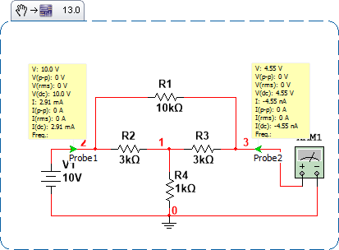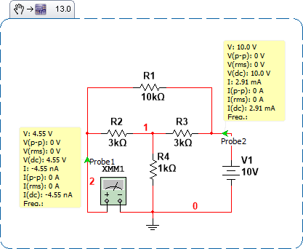

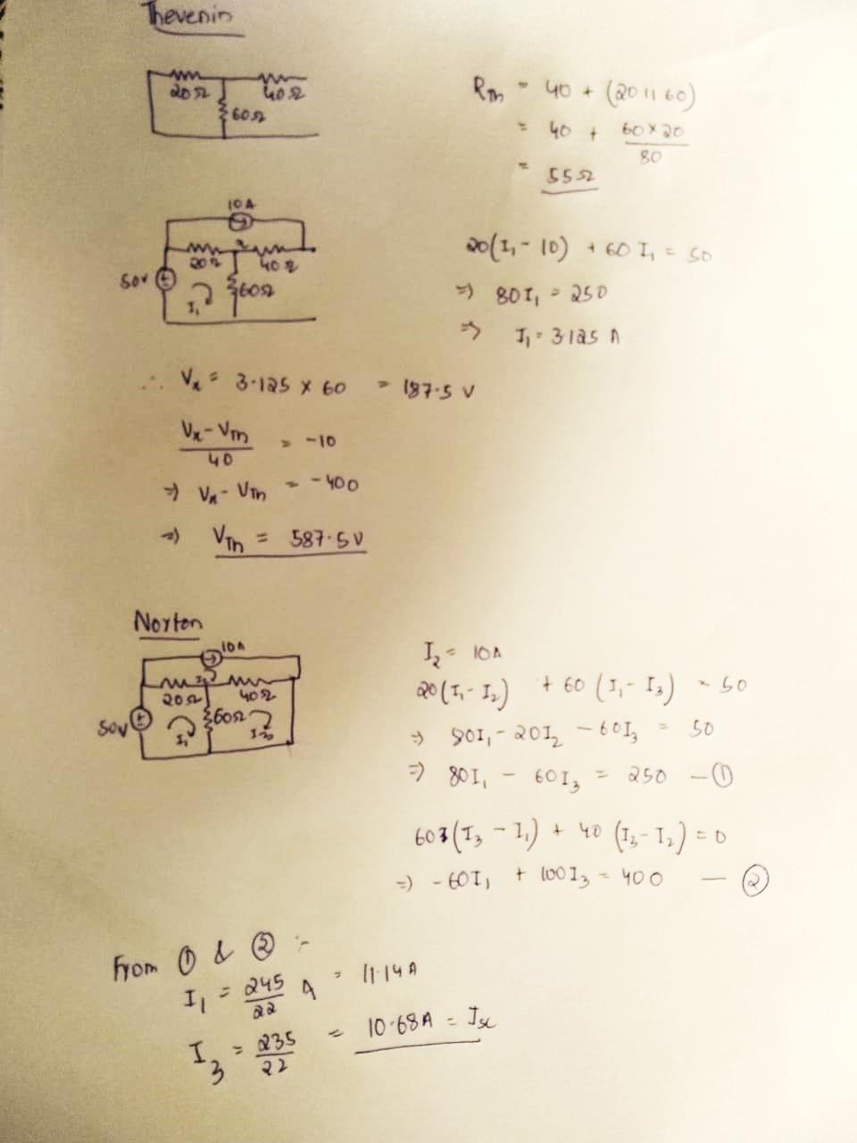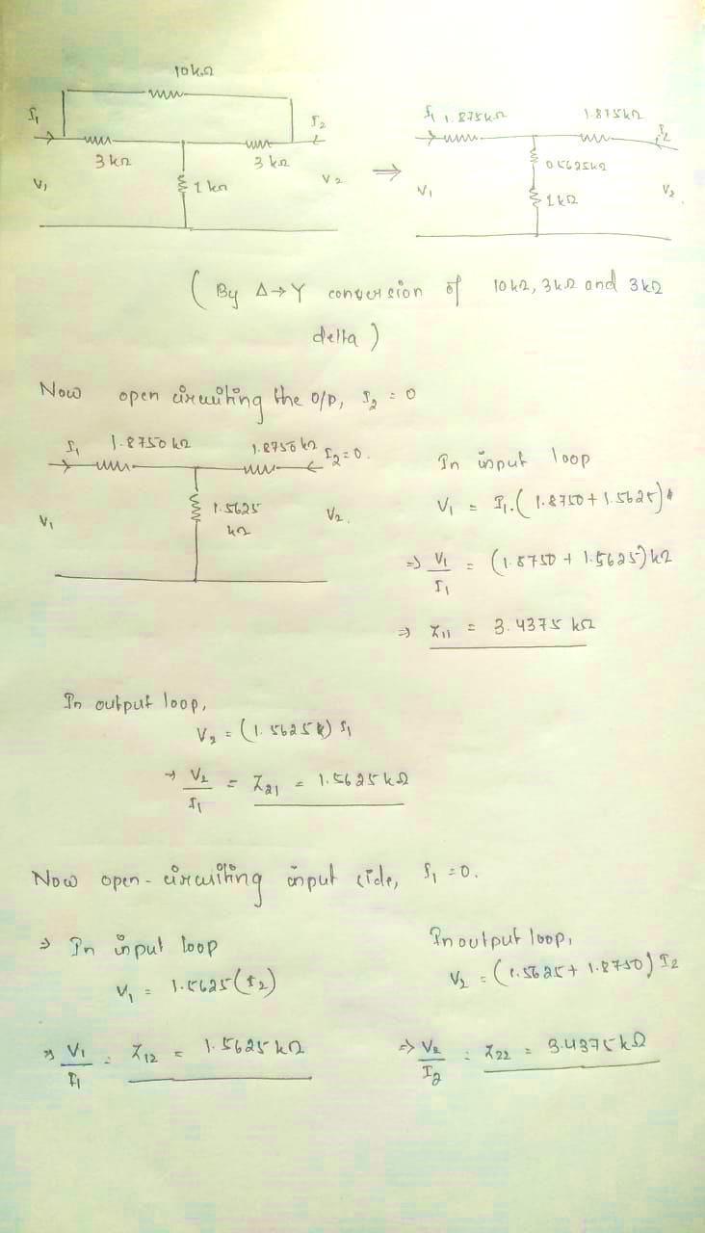

1. **Explain whether this two-port circuit is reciprocal, and why?**
2. A two port network will be reciprocal if the interchange of an ideal voltage source at one port with an ideal current source at the other port does not alter the ammeter reading.

Condition for reciprocal,

Thus, the above circuit is reciprocal.

1. **Explain whether this two-port circuit is symmetric, and why?**
2. A two port network will be symmetrical if the input and output ports can be interchanged without altering the port voltages and currents.

Condition for symmetric,

Thus, the above circuit is symmetric

1. **Run the simulation for a loaded two port network as shown in Figure 3 and find the voltage and current gain. Vs= 10 V DC, Gv=V2/Vs and current gain Gi=I2/I1.**